DOCUMENTATION OF TESTCASES FOR THE PROBLEM STATEMENT

Sample Files:

File1:

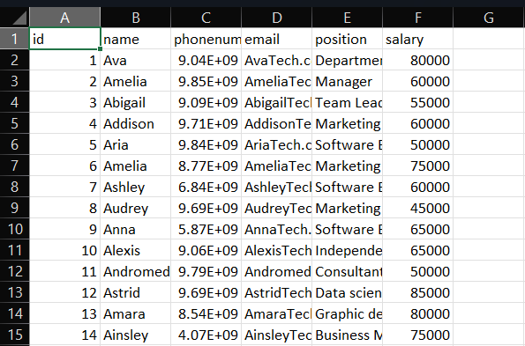

File2:

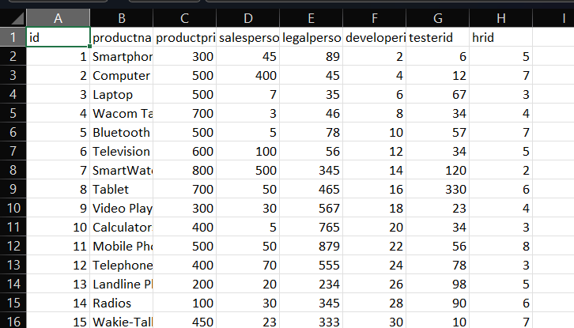

Data Validation Success:

Insertion of Data:

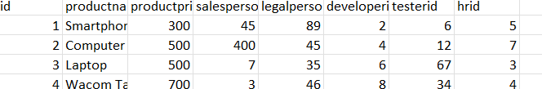

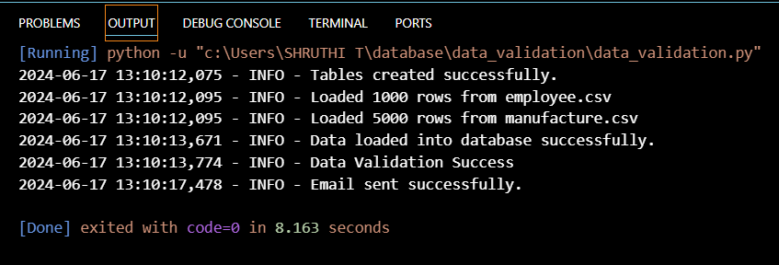

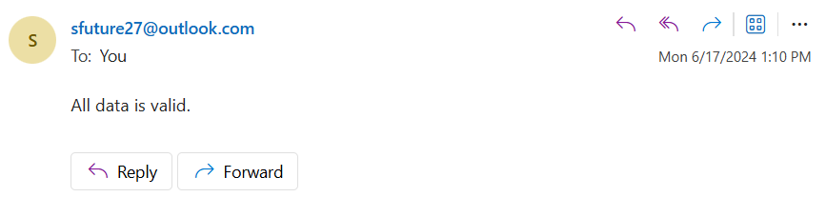

Deletion of Data:

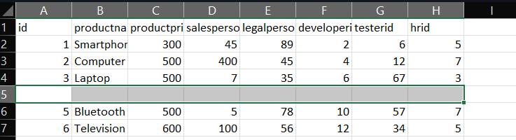

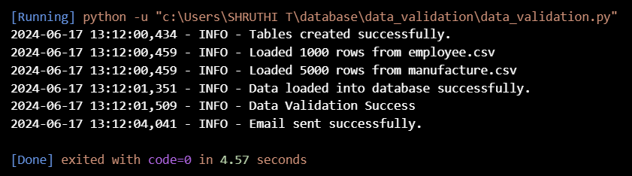

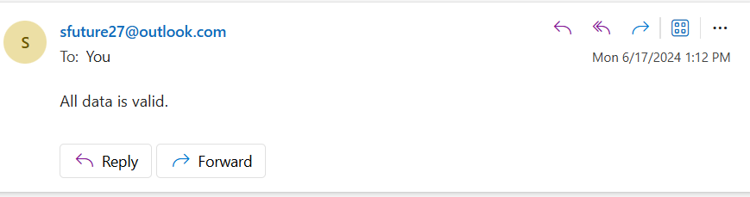

Data validation Failure:

